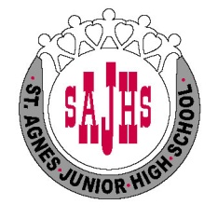

St. Agnes Junior High School
School Wide Code of Conduct

St. Agnes Junior High School, a proud community of diverse learners, is built upon a common purpose to acquire knowledge, develop skills and become responsible citizens defined by mutual co-operation, trust, respect and equity.

As a result, we expect St. Agnes community members to be courteous, considerate of others and their property, while showing tolerance and respect of others.

STUDENT RIGHTS AND RESPONSIBILITIES

1. I have the RIGHT to learn in this school.
It is my RESPONSIBILITY to be prepared to learn.
2. I have a RIGHT to hear and be heard.
It is my RESPONSIBILITY to respect other’s contributions.
3. I have a RIGHT to be respected in this school.
It is my RESPONSIBILITY to be considerate to other people.
4. I have a RIGHT to be safe in this school.
It is my RESPONSIBILITY not to threaten, and/or physically or psychologically harm anyone else at school or while going to and from school.
5. I have a RIGHT to privacy and to my own personal space.
It is my RESPONSIBILITY to respect the personal property of others and to accept their right to privacy.
6. I have the RIGHT to be treated with courtesy and respect by adults.
It is my RESPONSIBILITY to show respect and to treat courteously all adults in our school and the community.
7. I have the RIGHT to be knowledgeable about and proud of my ancestry and cultural heritage.
I have the RESPONSIBILITY to learn about and to be tolerant of the history and cultural background of others.

