**May 2, 2024**

**ST. AGNES JUNIOR HIGH**

**PRINCIPAL’S REPORT**

**Education Week:**

The following members of our school support team were honored with Gator Greats during Education Week (April 15-19th):

**Student Success Planning:**

Data pull #5 for math will take place on Friday, May 3rd. Grade 8’s will be writing the RWM8 on May 27th and May 28th for math and again on May 30th and May 31st for Literacy.

On May 3rd grade seven English teachers will be working with Melissa Trenbrith, HRCE Literacy Consultant, on our final cycle for Literacy. The focus will continue to be on writing conventions.

Paul Carreiro is starting with the ANS Achievement Grant. He will be working with grade 7 and 8 students two days a week until mid June.

Transition meetings will take place over the month of May for our students coming into grade seven and our grade nines entering high school.

**PD Sessions:**

Our April 4th PD sessions went very well. We focused on knowing out school community and the many challenges we face. After our session staff members were asked to come up with a “bite size” change we could make to our school culture. Great ideas were suggested many of which are already included in our planning for September.

Nancy and Sare will be continuing with Three Braids in May and June. Sara is also attending VP PD for new vice principals.

**Guidance:**

* HRM Citizenship Award is awarded to one Grade 9 student from each school in HRM; St. Agnes’ Recipient has been chosen – Congratulations to Tia Panopalis. She and her family will attend the Citizenship Award Ceremony at City Hall on May 7th
* Wudasie Adnet LG respectful citizenship award.
* Techsploration Students were invited to Pratt & Whitney’s Aerospace Manufacturing Plant on March 28th. They spent their day with Sara, their role model, who is a chemical engineer and heads up one of the three departments at the site. Fascinating and informative day for the students (and chaperones!) On May 30-31 students will be traveling to the Centre of Geographic Sciences (NSCC COGS campus) to continue their hands on learning journey.
* Our third round of Y-Mind programming is up and running. We have been very fortunate to have the YMCA facilitators at our school so much this year, and we hope that this relationship continues next year and beyond.
* Student Wellness Conference Day took place on April 25th and was a roaring success.
* Stephanie Hughes, School Counselling Practicum Intern, has completed her 4 month placement at SAJH. She has been an exceptionally strong addition to our staff while here, running girls groups, workshops on Healthy Boundaries with our grade 7s, offering individual counselling, and most recently prepping our O2 candidates for their interviews. We know she will be an amazing addition to a very lucky school in September.
* Grade 9 students who are applying for the Options and Opportunities Program for grade 10 are well along in the process. They have submitted their applications, many have taken advantage of mock interview prep, and we are now waiting for the Coordinator of the program to let us know when she will be at our school for interviews.
* The Youth Project came to St. Agnes on April 11th and provided interactive workshops to our grade 7 students. In line with the curriculum for junior high, the two presenters were very engaging and focused on encouraging youth to become inclusive allies regarding people’s sexual orientation and gender identities.
* We were honoured to have Marlene Companion, Mi’Kmaq Elder, at our school on April 16th to help us formally recognize the new art installation above the ramp. The art was created by the grade 9 students with the support of Colin Briggs, HR Arts Indigenous Art Specialist, who was also in attendance. Marlene spoke with the students, offered a blessing, and then the gathering moved outdoors for a smudging ceremony.

**Student Wellness Conference Day:**



**WorkIt Grant:**

Mr. Gallant has begun his Cutting Board Project with grade 9 students. Thanks to the WorkIt Grant, the St. Agnes wood shop has some great new tools that will help make the cutting boards look professional.

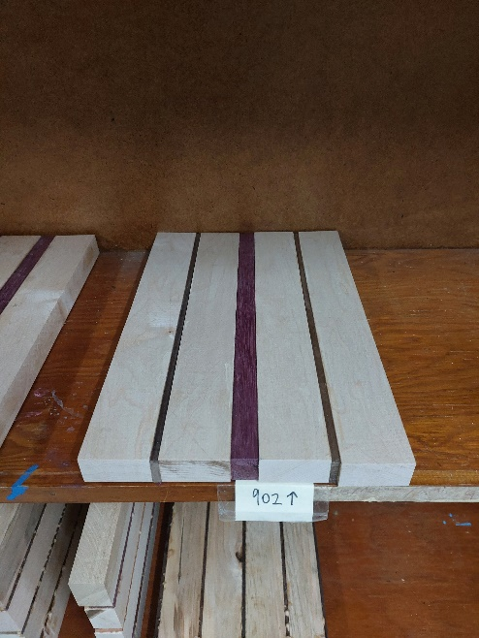

**Clubs and Sports:**

**Our Techsploration group** will be visiting their mentor, Sarah Lewis, who is a chemical engineer with Pratt and Whitney on March 28th. They will then be creating a presentation for the Techsploration event in the Valley at the end of May.

Badminton season has come to an end. Students participated in two tournaments; one at Citadel and another at Scared Heart.

**Early Morning Gym** continues to be a great success with many students attending every Thursday. Dr. Harrison