October 9th, 2025
ST. AGNES JUNIOR HIGH
PRINCIPAL’S REPORT

What’s been happening since we opened:
PD Focus
Safe Schools and the New School Code of Conduct
Mission Statement

Student Success Planning
Working on our goals for Cycle One with a focus on grade 8 literacy and numeracy and full school Well Being. Goals will be shared at the next meeting.

We Are Not That Kind of School
New signs and student led sessions
Mission Statement

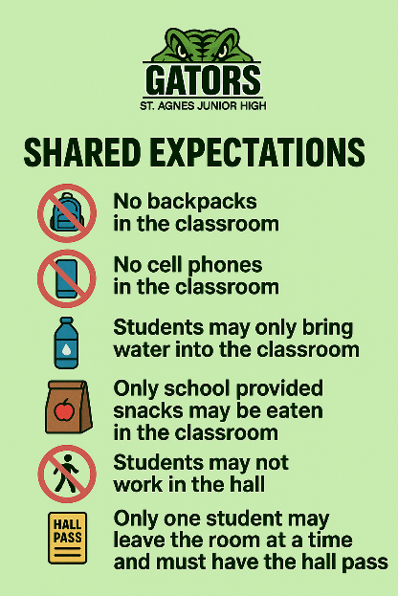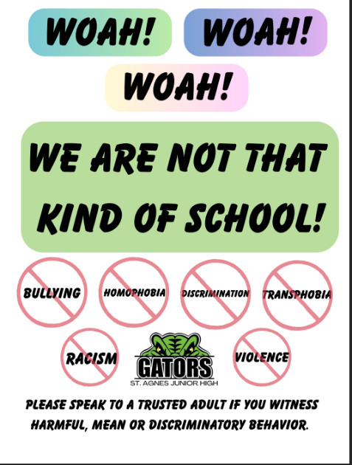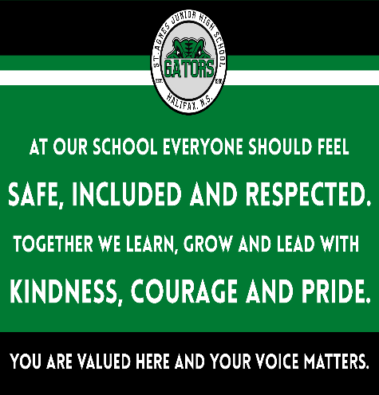

New staff (8 teachers, 1 counsellor, 3 EPAs)
Current enrollment (361)
EAL now full time
Curriculum Night – new structure was well received by the community and staff.
Painting of Doors – ongoing for the next month

New Art and bench:

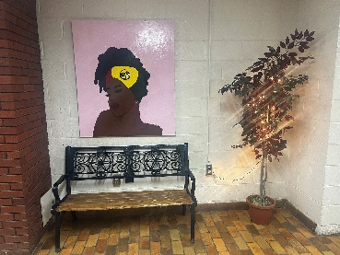

Pink Day – ILT activities
Gator Greats for student and staff

Dramatic Math:

Mr. Chan and Ms. Tufts (Halifax Regional Arts Fine Arts Specialists) brought the art of drama to Mr. Chan’s grade 7 math classes. A lesson in plotting points on a graph became an interactive and dramatic performance of working together to make shapes on a large graph located on the library floor.

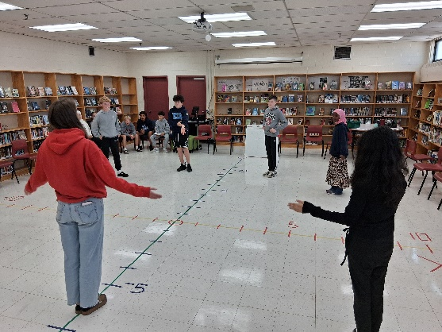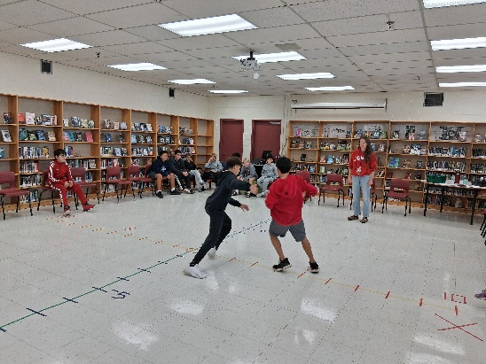

Mi’kmaw History Month:
On September 26th students and staff wore orange shirts in honour of Truth and Reconciliation Day. During first period on the 26th all students engaged in a school wide lesson on the meaning of Truth and Reconciliation Day, as well as videos on Residential Schools and how to become an Ally to our indigenous communities. At the end of the lesson students wrote words on vinyl feathers to symbolize how the students in residential schools may have felt. These Feathers will be placed on the wall in the grade seven hallway as a beautiful art installation to honor the children of Residential Schools.

On September 18^{th,} 20 of our students, several of whom identify as indigenous, attended a Youth Empowerment Event called,” The Gifts We Carry. This event was held at the Scotia Bank Center to honour Residential School Survivors. A link to this very powerful event is below:

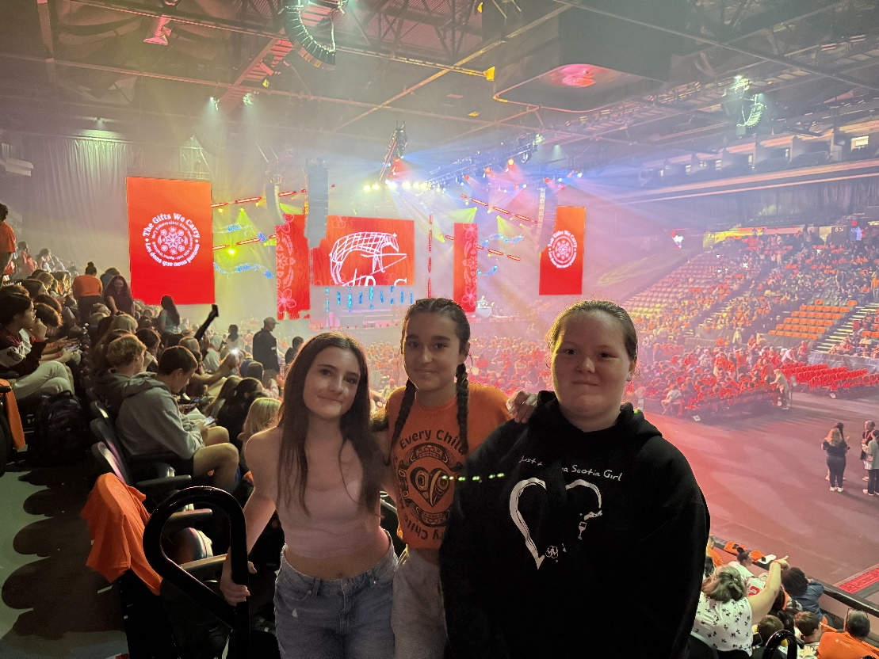

https://cdn.halifax.ca/sites/default/files/documents/city-hall/boards-committees-commissions/250813seac732pres.pdf
Lunch Program:
Lunch program started on October 6th. Our food is being made by Upward Mobility Kitchen. Things are going really well and we are hoping to give out the left over meals to community partners.

Student Success Planning:
- Paul Carreiro is continuing his time at St. Agnes in the roll of ANS Support Grant Teacher.
- Asked for a math coach
- Currently in cycle one
Guidance:
- 5 of our ANS female identifying students are going to MSVU for a conference called Black Girls Rising. It is a day to celebrate the power of girls, champion their rights, and address unique challenges they face worldwide. This will take place on October 10th.

- On November 18th and 19th, our Grade 9 students will take part in presentations on consent led by Dalhousie Law students. These sessions provide valuable knowledge to help students better understand consent in a safe, respectful, and informed way, preparing them to navigate these conversations both in their school years and into adulthood.
About the Presentations
The World Health Organization and a report commissioned by Students Nova Scotia emphasize that a comprehensive sexuality curriculum—including consent education—can play a critical role in preventing and addressing sexual violence.
By engaging students in a safe, educational setting, this program equips them with the essential knowledge to navigate consent both during their school years and into adulthood. With a collaborative and educational approach, we aim to strengthen community understanding and take a preventative stance on sexual violence in Nova Scotia.
The need is clear:
In Canada, 15–24-year-olds experience the highest rate of sexual assault.
Before reaching postsecondary, children and youth account for over 50% of all police-reported sexual assault victims.
At the postsecondary level, over 70% of students report witnessing or experiencing sexual violence, with first-year students especially at risk.
A major factor is a lack of understanding of consent, often compounded by alcohol consumption, which can be weaponized to facilitate sexual assault. This reality underscores the importance of early, clear, and ongoing education about consent—something this program directly addresses.
- Our Grade 8 students will be welcoming the Youth Project into their classrooms on October 16th. This organization works to support 2SLGBTQ+ youth and foster safe, inclusive learning environments. In addition to their classroom visit, the Youth Project will be collaborating with the St. Agnes GSA (Gender & Sexuality Alliance) throughout the year on a variety of special projects designed to celebrate diversity and strengthen our school community.
- Support for Grade 9s during their transitional year to Citadel High will also continue, with Ms. Hughes visiting classrooms and providing 5-minute individual check in's with students to help guide them socially, emotionally, and academically as they prepare for the next stage of their education.

- As part of our continued focus on the school’s Wellness Goal, we are building on the “We’re Not That Type of School” program, which promotes respectful relationships and a positive school climate. After reflecting on last year’s data, it was clear that students wanted more peer involvement. In response, we created an Equity Team made up of Grade 9 students. This team will assist with delivering the program to all grade levels, while also contributing to planning and offering suggestions to ensure the initiative continues to grow.

- Professional development is also an important part of supporting our students. On October 15th, Ms. Hughes will attend training offered by HRCE in collaboration with the Departments of Education and Early Childhood Development, Labour, Skills and Immigration, Advanced Education, and the Nova Scotia Apprenticeship Agency. The day will provide updates and resources around student services and equity, labour market information, skilled trades programming in schools, youth apprenticeship pathways, myBlueprint counsellor supports, the Nova Scotia Works School Liaison Program, and career resources in the skilled trades. This professional learning will strengthen our ability to guide students as they explore their future opportunities and career pathways.

- Another exciting initiative this fall is Take Our Kids to Work Day, which returns on Wednesday, November 5, 2025. Grade 9 students will take part in this landmark Canadian program, which continues to inspire the next generation of leaders through both in-person and virtual career exploration. This year’s theme, Lift Up the Future, calls on us to support young people as they explore their potential and imagine the world they want to build. Led by the Students Commission of Canada and supported by RBC, the day brings together students, families, educators, and employers for a meaningful opportunity to discover, connect, and be inspired. Take Our Kids to Work, a landmark Canadian program dedicated to inspiring the next generation of leaders, returns on Wednesday, November 5, 2025. For its 31st edition, the event continues to evolve, with new opportunities for both in-person and virtual career exploration. This year’s theme, Lift Up the Future, is a call to support young people as they explore their paths and imagine the world they want to build. By encouraging this journey, we not only help them uncover their potential — we also strengthen our communities and lift up the future for all. Led by the Students Commission of Canada (SCC), and made possible thanks to support from RBC, this national event brings together students, families, educators, and employers to create a meaningful day of discovery, connection, and inspiration.

- A MADD Canada presentation is being scheduled for the whole school in November. This important session will focus on the dangers of impaired driving, the importance of making safe choices, and the role of prevention and awareness in keeping our students and community safe.

Sports and Clubs:
- The St. Agnes female-identifying soccer team has kicked off the season with amazing effort and spirit! So far, we’ve had a hard-fought tie and two close games that showed our team’s growth, perseverance, and sportsmanship. A huge shoutout to our incredible Grade 9 leaders for their positivity and leadership on and off the field—they’re setting the tone for what teamwork truly looks like. And of course, special recognition to our goalie, whose quick saves, fearless attitude, Goodness keep us in every game! We’re so proud of this group and can’t wait to see what the rest of the season brings. Go Gators!!

- Our Male-Identifying Soccer Team has had a strong start to their Fall season. After several productive practices, they kicked off the season with a victorious first game against Park West (2-0). With continued dedication and teamwork, the team is now well into the regular season. We would like to thank our volunteer coaches, Mr. Mirtchev and Mr. Starzomski, for their commitment and support. The team has several exciting games ahead before entering the playoffs in late October. We wish our Gators, who have been in the Final the past four seasons, the best of luck as they continue their journey this season!

- The St. Agnes Cross Country team is off and running in another season. Lead by a team of strong intermediate girls, our Gators are primed for a competitive shot at regional and provincial banners this year. The first meet of the year was only for Jr. High's, held at Point Pleasant Park. Our Gators represented well with excellent finishes from Dominic Ngyuen, Grace Ferguson, Emma Laycock and Sam Terrio who all finished in the top 10 of their categories. October 9th will mark our Capital Regional Championships where the Gators will compete for a chance to qualify for SSNS Provincials on October 20th. Go Gators!

- Early morning gym with both Mr. Seeley (Wednesday) and Mr. Brown (Two mornings each week. Not always the same)
- Student Council
- Art Club
- D and D Club
- Yearbook
- Volleyball – tryouts are complete and season prep as begun.

- Shared Expectations for all Extra Curricular activities have been created and sent home to all families.

In the Works:

- Newcomer night – November 6th.
- Report Cards – Week of November 24th
- Progress Conferences – December 3rd and 4th
- Lockers – currently looking at the process to replace.

